**KEY METRICS & INSIGHTS ON BIKE BUYERS**

1. **Introduction**

The purpose of this Project is to analyse bike sales data to derive meaningful insights and inform decision-making processes. The dataset used includes various attributes such as marital status, gender, income, education, occupation, and more. This report will cover the visualizations created, their interpretations, and actionable insights based on the data analysis.

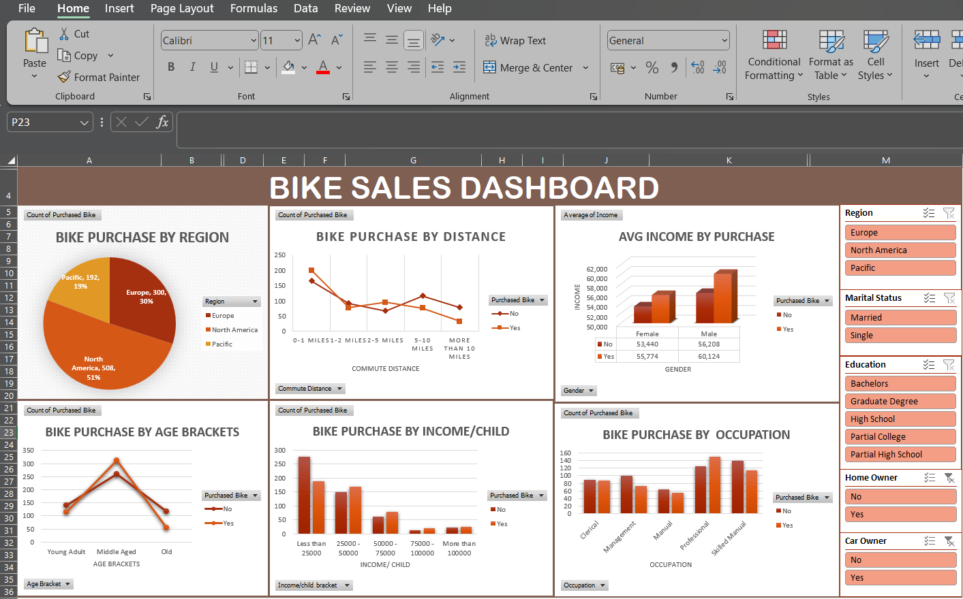

1. **Visualization Analysis**
   1. Bike Purchase by Region

* Visualization: Pie chart showing the percentage of bike purchases across different regions (Europe, North America, Pacific).
* Insight: North America leads with 51% of purchases, followed by Europe (30%) and the Pacific (19%).
* Action: Focus marketing efforts on Europe and the Pacific to increase sales, while maintaining strong campaigns in North America.

2.2 Bike Purchase by Distance

* Visualization: Line chart depicting the relationship between commute distance and bike purchases.
* Insight: Purchases decrease as commute distance increases. The highest number of purchases occurs within 0-1 miles.
* Action: Highlight the convenience of biking for short commutes in marketing campaigns. Consider opening stores closer to residential areas to attract more buyers.

2.3 Average Income by Purchase

* Visualization: Bar chart comparing the average income of bike purchasers vs. non-purchasers, segmented by gender.
* Insight: Bike purchasers generally have higher average incomes, with male purchasers earning more on average than female purchasers.
* Action: Develop marketing strategies that appeal to higher-income groups. Emphasize the value and benefits of biking for both men and women.

2.4 Bike Purchase by Age Brackets

* Visualization: Line chart showing bike purchases across different age brackets (Young Adult, Middle Aged, Old).
* Insight: Middle-aged individuals are the most likely to purchase bikes.
* Action: Target middle-aged consumers with specific marketing messages and promotions. Consider product features that appeal to this demographic.

2.5 Bike Purchase by Income per Child

* Visualization: Bar chart displaying bike purchases based on income per child.
* Insight: Families with less income or more children are the most frequent bike purchasers.
* Action: Create family-friendly marketing campaigns and promotions that highlight the affordability and benefits of biking for families in this income bracket.

2.6 Bike Purchase by Occupation

* Visualization: Bar chart illustrating bike purchases by different occupations.
* Insight: Skilled Manual and Professional occupations have the highest bike purchases.
* Action: Customize marketing efforts to appeal to these professions. Highlight the utility and benefits of biking for both skilled manual and professional workers.

**How the Dashboard Was Created**

**Data Preparation**

* **Step 1:** Gathered and cleaned the dataset by removing null values and ensuring correct datatypes for each column, ensuring all necessary attributes were included.
* **Step 2:** Created additional columns for Age Bracket, Income per Child, and Income/Child Bracket and car owners to facilitate detailed analysis.

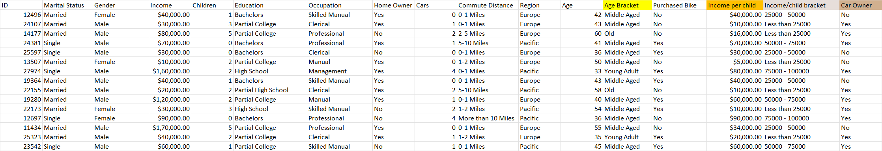

**Visualization Creation**

* **Step 3:** Used Excel to create various visualizations including pie charts, bar charts, and line charts.
* **Step 4:** Added slicers for Region, Education, Marital Status, Homeowner, and Car Owner to enable interactive analysis.

**Analysis and Interpretation**

* **Step 5:** Analysed each visualization to identify key trends and insights.
* **Step 6:** Documented the insights and developed actionable recommendations based on the findings.